**Project 2 – Proposal**

**Paul Dean ∙ Soobin Hwang ∙ Seunghwa Jun**

**Outline of the Project**

* **Team Name : Team Phono Sapiens**
* **Team Members : Paul Dean, Soobin Hwang, Seunghwa Jun**
* **Topic : Creating ① the Reference List DB and ② the Interactive Website**

for the book titled << *Phono Sapiens Economics : The New ‘Human-*

*Centered’ Digital Economics* >> which was published in Korean in this

September and will be e-book published in English in January 2020.

(Team members’ names will be listed in the ‘Acknowledgements.’)

* **Data Set : References of the book (will be manually created by the author)**
* **Database : SQLite of MongoDB**
* **Visualization : Menus, Dropdowns, D3.js / Plotly graphs and views.**
* **Github Repo : https://github.com/SeunghwaJun/PhonoSapiens**

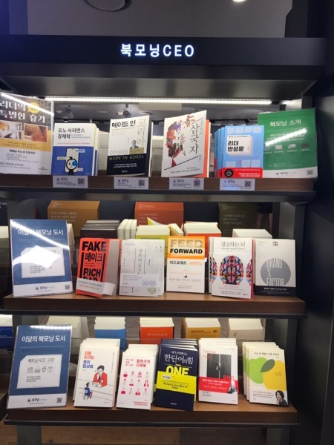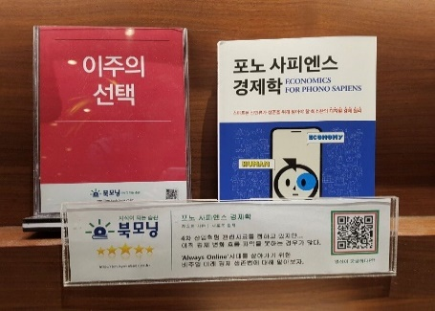

**Project 2 – Proposal**

**Relevant Visualization Examples**

**① Menus, Dropdowns : Part / Chapter / Page / Institution / Language / Title / URL**

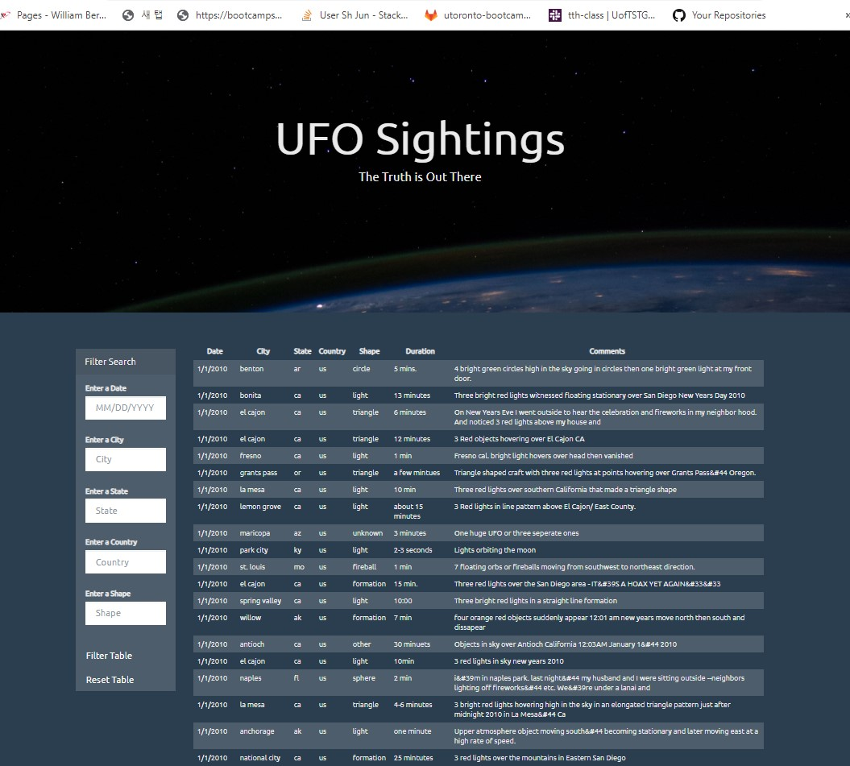

Dropwdown will be applied for 4 buttons (Part / Chapter / Institution / Language)

Filter Search will have 5 buttons (Part / Chapter / Page / Institution / Language

**② Visualizing the Data : Number of references by Part, by Chapter, and by Institution**

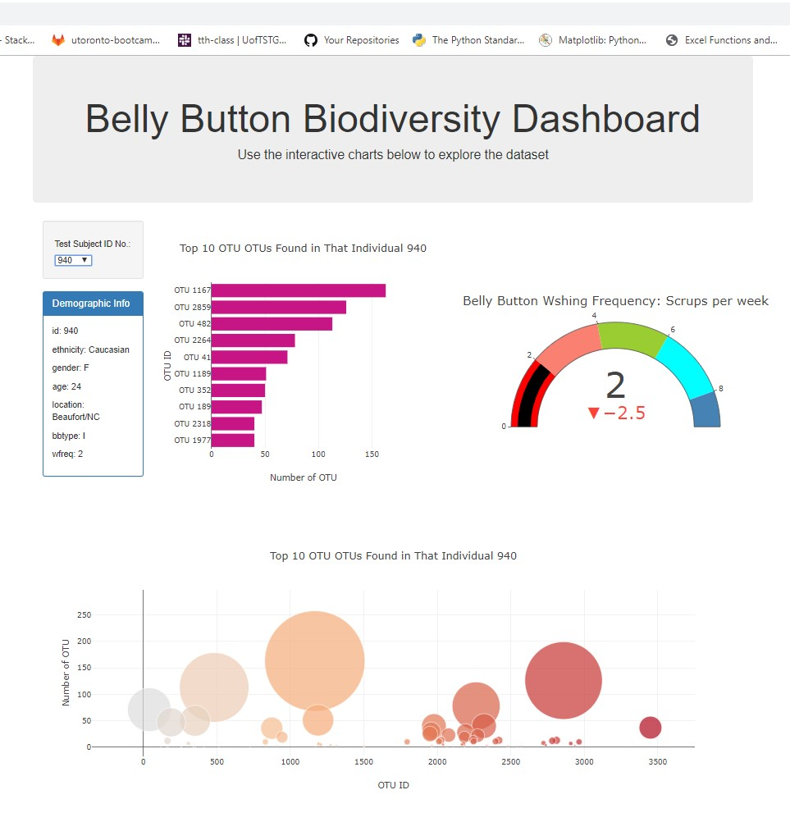

Dropdown by Institution will show the total number of references of the institution, and each number of references by part.

=> Choose one institution! (Default McKinsey)

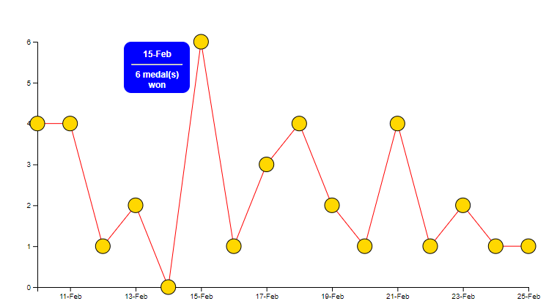

Chosen institution’s total number of the references will be shown, compared to the median number of references of the top 10 institutions.

Chosen institution’s reference number by part will be shown.

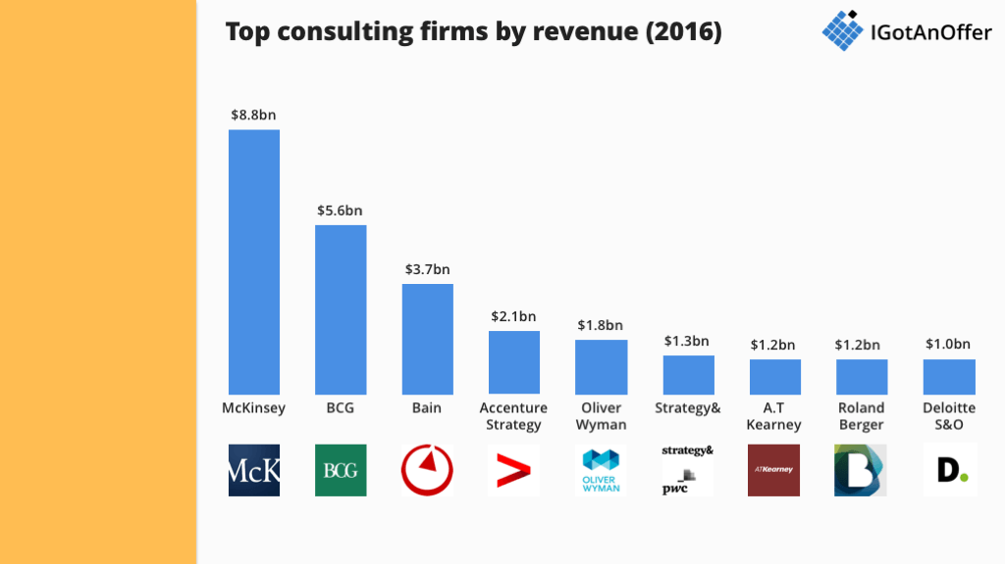

Name of the institution will be at the background

The total number of references of the top 7 Institutions will be visualized, and when clicking the institution name will like to its homepage.

Base CSV data will be like this.



**③ Scraping the Data : Recent Reports/Tweets of the Institutions**

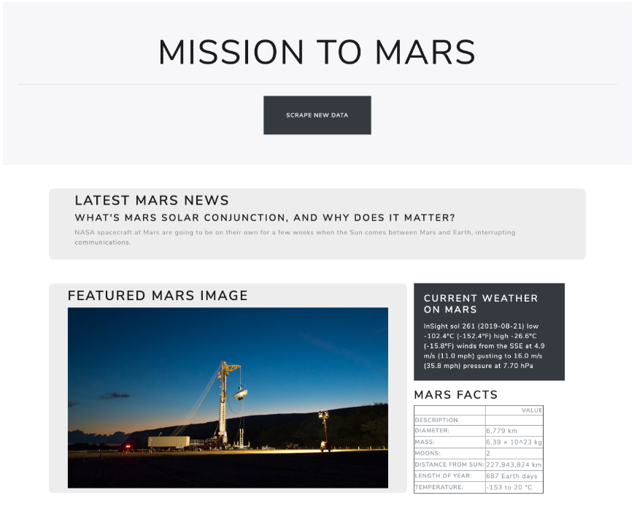

Scraping Reports/Tweets of the Institutions